

**User Manual**

**Robert Decrescentis**

**Table of Contents**

1. **Introduction............................................................................................3**
2. **Getting Started......................................................................................3-7**
3. **Portal………………........................................................................................8**
4. **Business Registration………….....................................................................9**
5. **Business Listings……….........................................................................10-12**
6. **Business Contact Information.............................................................12-13**
7. **View Business Contacts…….................................................................13-16**
8. **Developer Contact Information...............................................................17**

**Introduction**

Welcome to the ContactManager website. This website is designed to allow ContactManager employees, managers, and non-employees to register, login, add business listings and business contacts, view, edit and delete business listings and contacts, using back-end web application technology. Our website will provide ContactManager employees with a list of business listings and contacts for business use. An employee will be able to register business listings through business name, phone number and address. Furthermore, employees will be able to register business contacts by first and last name, phone number, email and business name. Once a employee issues a business or contact request, they are able to search and modify (i.e. edit or delete) it based on business need. Additionally, clients will be able to log into the site to perform each task.

**Getting Started**

The ContactManager website is designed with state-of-the-art technology (i.e. HTML5, CSS3, Bootstrap, JavaScript) so that users will have an optimum experience. The home page includes a navigation bar with links that direct users to sections within the website. It also includes the following sections within the home page: About, services and team. The about section explains the versatility of the ContactManager software with its functions. The services page provides information about the languages, functionality, support and design of the ContactManager software. FAQ’s also include questions and answers that are frequently asked. The pricing tables include various features if a user would like to purchase the ContactManager software. Each table explains what is included with a monthly subscription. A separate contact page was created so that users can be directed to complete a contact form for more information about ContactManager.



Figure 1. Home page for ContactManager. Includes navigation bar, about, services, FAQ’s, team, pricing table and footer.

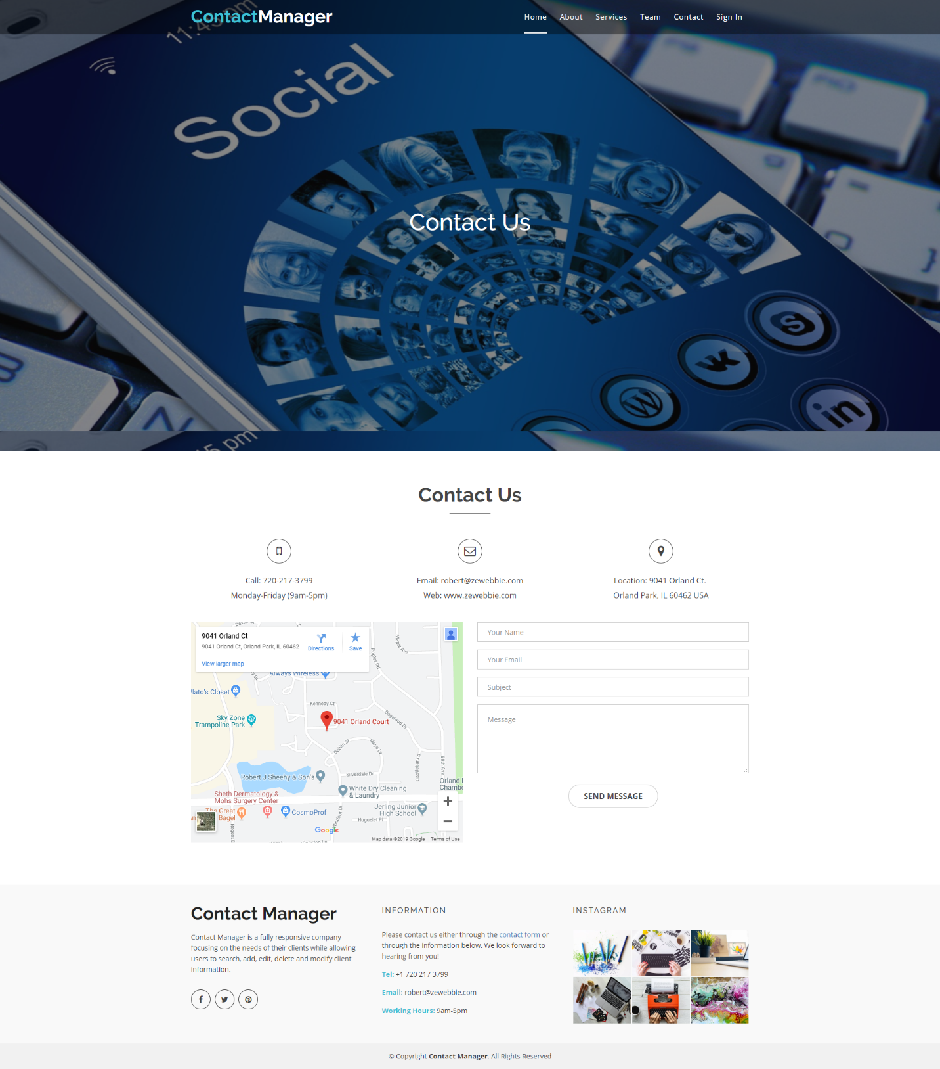

Figure 1. Contact us page with navigation bar, contact form and footer. User completes the fields and clicks send message. Message is sent to [robert@zewebbie.com](mailto:robert@zewebbie.com).



Figure 1a. Home page with Sign In link within navigation bar

Users must click on ‘Sign In’ on the navigation bar to access the login page. Once on the login page, users must register for an account to gain access to the ContactManager. Users must provide their first and last name, phone number, email, date of birth, username, password, confirm password, and choose from the drop-down list if they are an ‘employee, manager or non-employee’.

**Please Note:** if the user does not select an option, they will not have access to functions within the portal. After registration, the user will be redirected automatically within 10 seconds to the login page.

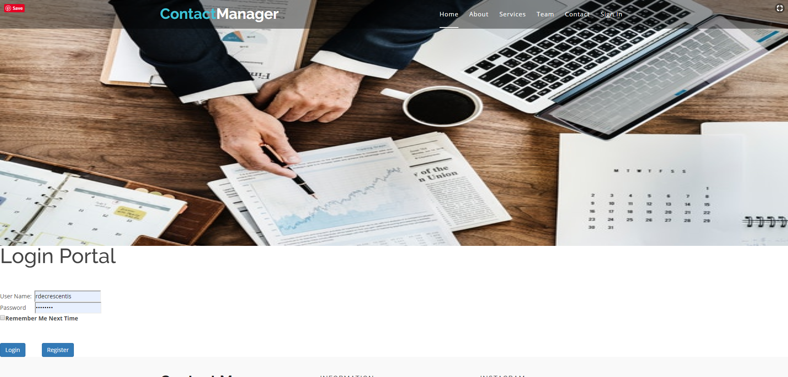

Figure 1b. Login portal with register button which links to registration page

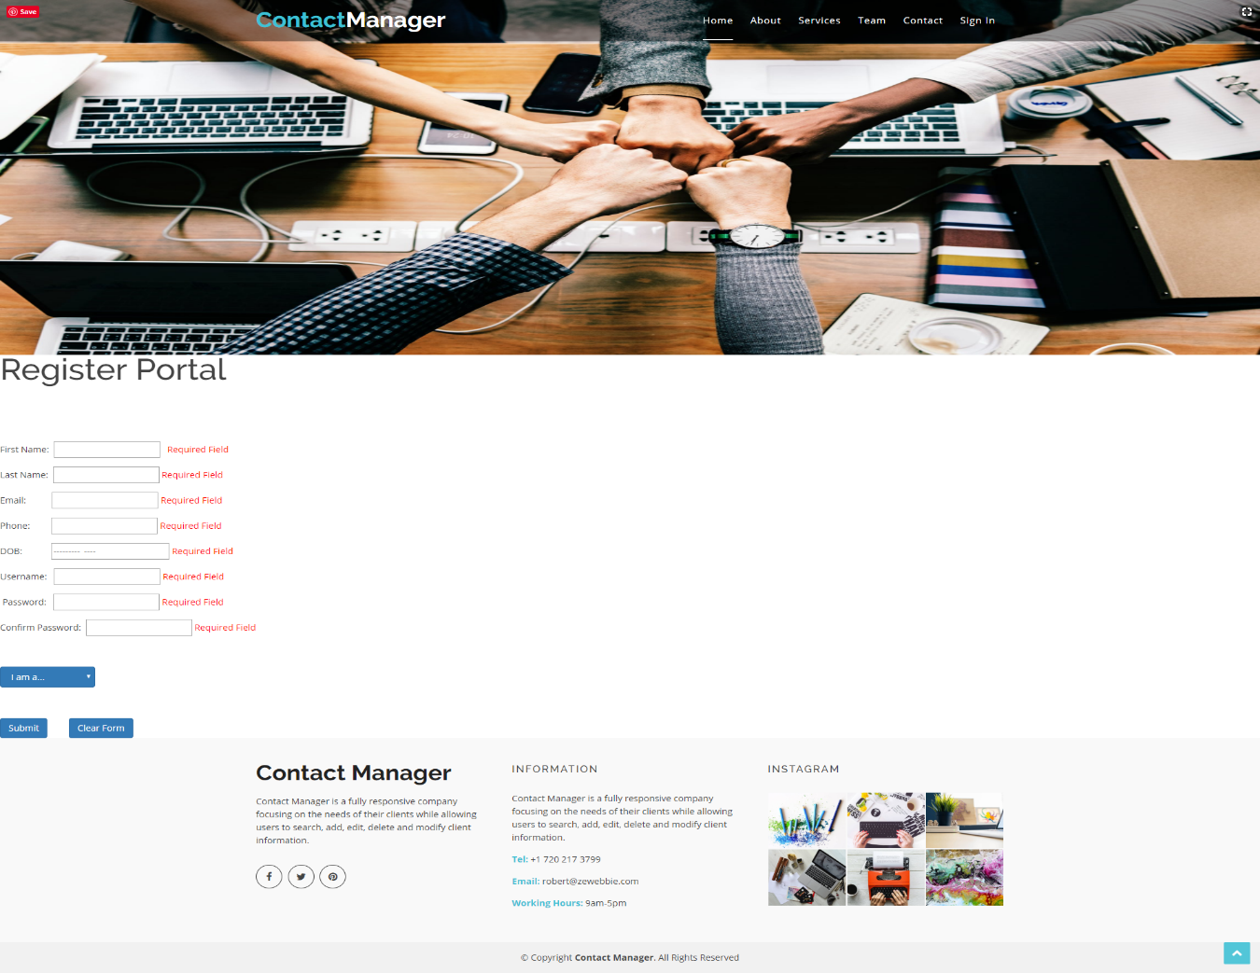

Figure 1c. Registration page with first and last name, email, phone number, date of birth, username, password, confirm password and employee type drop down fields with required field validation.

**Portal**

After registration and login, an employee will have the ability to choose a function within the portal. For example, business registration, business listings, business contact registration and business contact listings are options for employees to select. The portal has a modern user interface with a navigation bar, hero image, introduction and footer.

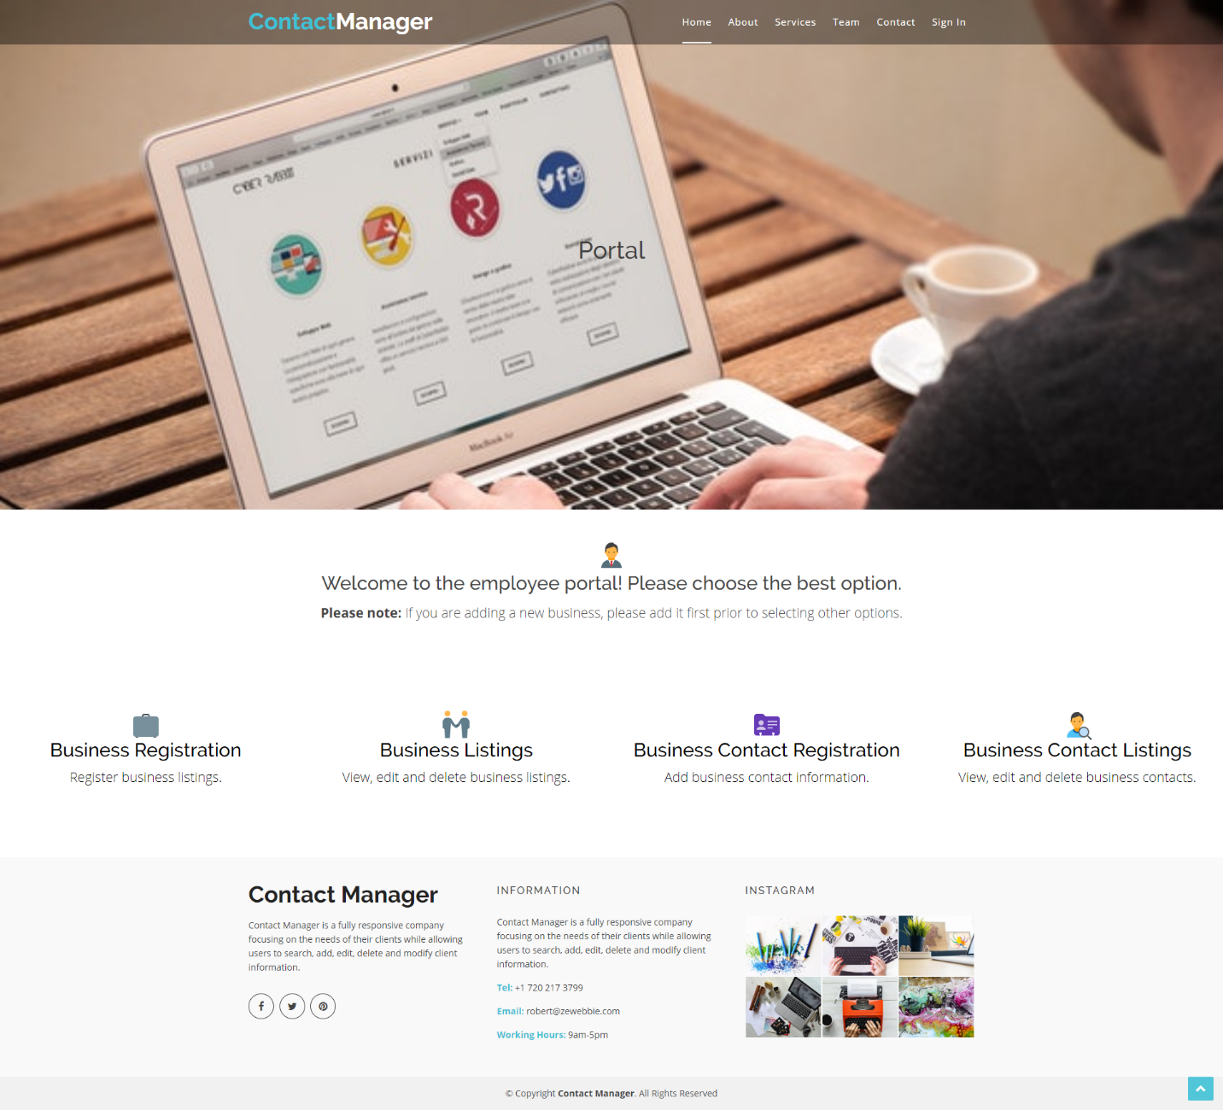

Figure 2. Portal page with navigation bar, hero image, basic introduction, footer and user selections for business registration, business listings, business contact registration and business contact listings.

**Business Registration**

Once the user selects the business registration link within the portal, they will be redirected to the business registration page. The business registration page will allow users to add business information to the database for later use. For example, business name, address, phone number and company type will be included to save the business listing. Users must enter business name, address and phone number to submit. If not, required field validators will appear prompting the user to populate information.



Figure 3. Business registration page which allows users to input business name, address, phone number and select company time to submit. Includes navigation bar, footer, submit, clear form and back to portal buttons.

**Business Listings**

The business listings page will display listings based on user input. Each listing was provided by the user on the business registration page. The user must type the information in the fields to display the information within the table. For example, business name, phone number and address must be typed to return results. The drop-down list includes categorization of business type (i.e. Government, Public and Private). Once completed, the user can click the ‘Search’ button and the desired results will appear.

**Please Note**: If the user does not place information in the textbox fields, all results will be displayed.

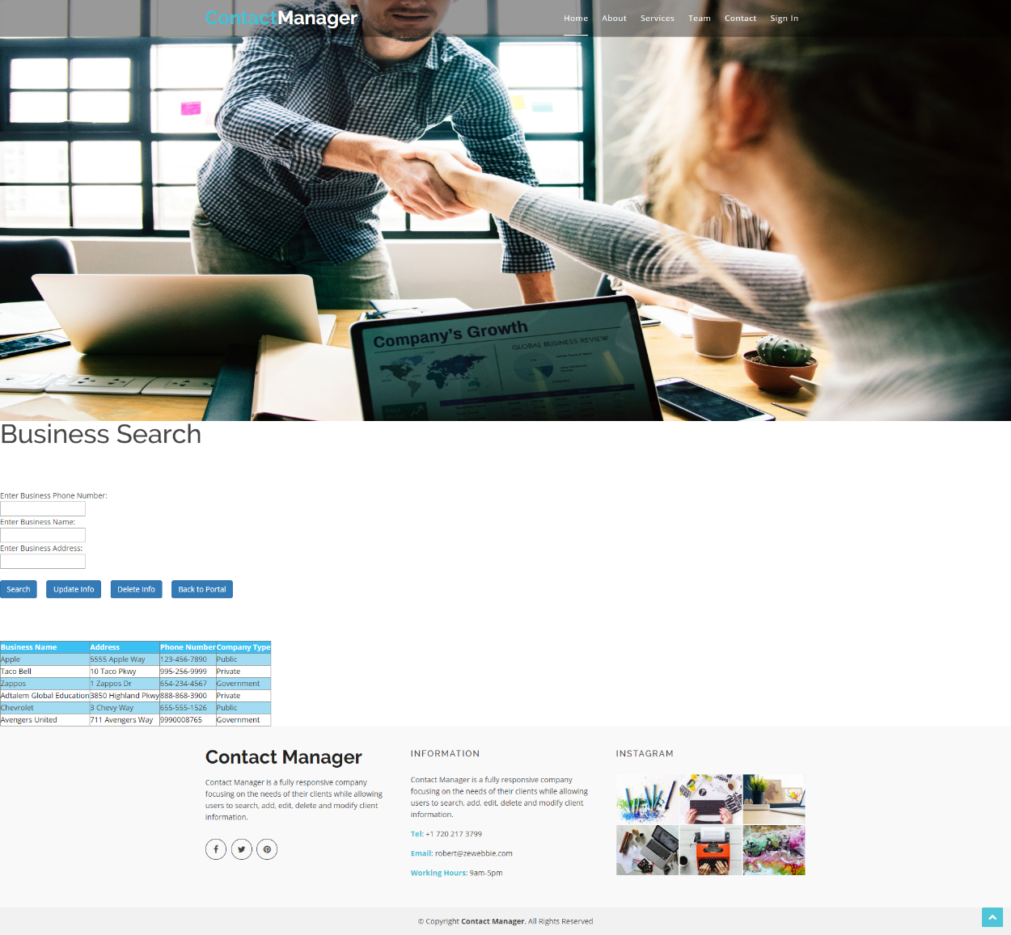

Figure 4a. Business search page with textbox fields for phone number, name and address. Includes buttons for search, update info, delete info and back to portal. Screenshot displays all information if fields are not filled out.

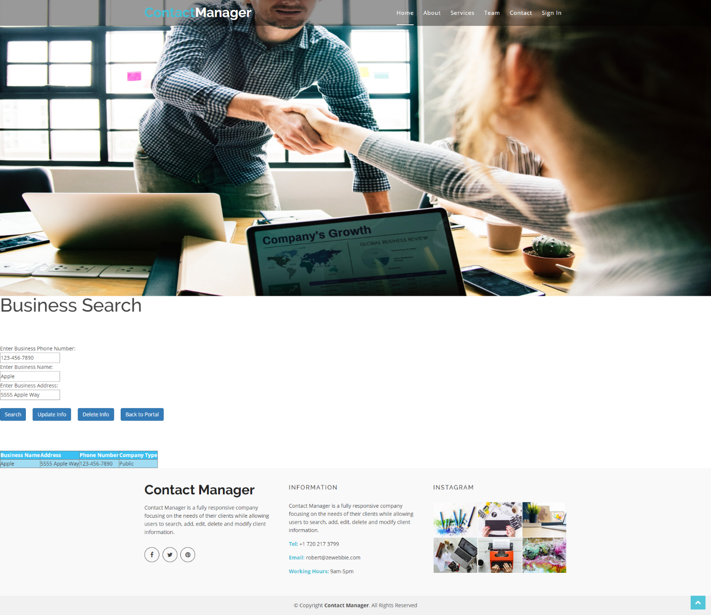

Figure 4b. Business search page with fields filled out and returned search results.

Users have the ability to update and delete information from the business search page. They must fill out desired fields to modify and click either ‘update info’ or ‘delete info’ buttons to execute actions. Once completed, a message will state the information was modified. If a user updated the information, they must click search to view modification. When the user is done, they can click the ‘back to portal’ button to link to the portal.

**Please Note:** Once a user clicks either update info or delete info buttons, the actions cannot be reversed.

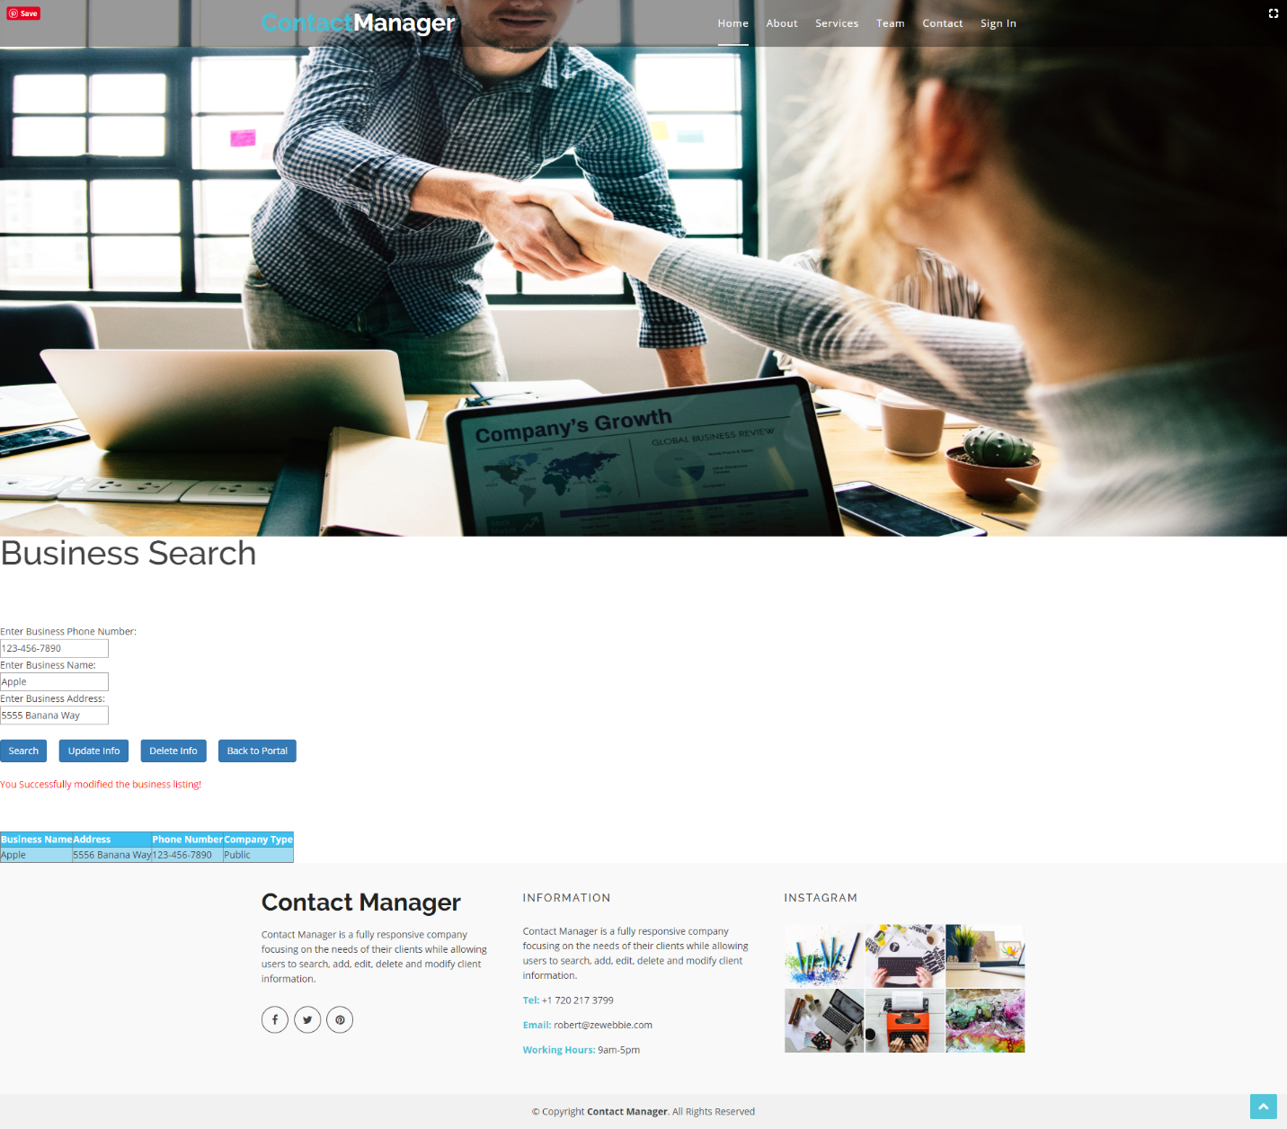

Figure 4c. Business search page with update info and delete buttons are clicked. Message appears once modification is performed.

**Business Contact Registration**

Users will have the ability to register contacts within a business. The business contact registration page includes fields for first and last name, email, phone number, date of birth and business name. An option to clear the form allows users to re-input information for correction. Once completed, users can click the submit button and will be redirected to the portal. If the user did not intend to enter the business contact registration page, they can click the ‘Back to Portal’ button to redirect back to the portal.



Figure 5. Business contact registration page with navigation bar, footer, first and last name, email, phone, date of birth and business name fields. A redirect message appears once users complete fields and submit.

**View Business Contacts**

The view business contacts page allows users to search, update and delete user information based on information provided within the textbox fields. Students must complete the business name, contact first and last name, and email fields to populate result. If the user does not complete the fields, all results will populate.



Figure 6a. Business contact page with search, update and delete info, and back to portal buttons. Includes navigation bar, hero image and footer.

Once a user submits the information and clicks ‘Search’, a table will display with the desired results.

**Please Note:** If the user would like to return multiple results with the same business, they need to only complete the business name field.



Figure 6b. Business contact page with fields completed for search result.

Users have the ability to update and delete information on the business contacts page. If a user wants to update information, they must complete all fields with desired updated information and click ‘Update Info’ button to submit. Users have the same ability for the delete option. If a user would like to delete information, they must complete all fields and press the ‘Delete Info’ button to proceed. A message will appear stating the listing was modified.



Figure 6c. Business contact page with fields completed for update and delete info requests. Image represents if the user completed the update task.

**Contact Information:**

Robert DeCrescentis

720-217-3799

decrescentisr@gmail.com